Market Reaction to M&A Announcement:
Impact of Taking Entrepreneurial Firms on Competitors’ Value

ABSTRACT
Mergers and acquisitions (M&A) could result in either competitive threats or opportunities to the acquirer’s industry. Building on the arguments raised in the competitive advantage theory and signaling theory, this paper will examine how M&A affects competitors in the industry. We suggest that the acquirer’s competitors would receive a more competitive threat when the target is an incumbent firm. However, the negative effect would be less in the M&A of entrepreneur firms. The analysis of data on M&A in US firms shows that M&A to acquire larger firms lead to negative cumulative abnormal returns (CARs) of competitors around the M&A announcement. The moderating effect of industry relatedness between acquirers and targets is also partly supported. This study provides meaningful insight for understanding the varying influences of M&A on the acquirer’s industry.

Keywords: Entrepreneurial firm; M&A; Competitor; Market; Event study

INTRODUCTION
When mergers and acquisitions (M&A) are announced in the industry, it garners the attention of investors and analysts in the industry (Andrade & Stafford, 2004). These events provide information to assess the market’s stream beyond the range of acquirers and targets (Chen, Hsu, Officer, & Wang, 2020). For example, when Intel announced its purchase of Altera, it drew attention to the semiconductor industry. Also, when Tencent announced its acquisition of Supercell, it became an issue for NetEase, Tencent’s biggest rival, and its shareholders.
The impact of M&A is divergent. They can influence the industry either positively or negatively. Some researchers show that M&A signals that market has undervalued the competitors in terms of their growth possibility or investment opportunity. According to the previous argument, competitors could earn positive cumulative abnormal returns (CARs) around its announcement as re-evaluation is progressed (Gaur, Malhotra, & Zhu, 2013). On the other hand, other studies advance that M&A can result in negative CARs to competitors if their competitive synergy is anticipated to threaten industry competitors (Akdoğu, 2009; Yang, Nam, & Kim 2017).
Several arguments have been advanced to understand the impact of M&A on competitors’ CARs. However, notwithstanding the progress in research, there remains ambiguity on which types of M&A positively or negatively impact the industry. In addition, there is a lack of knowledge about the target- and deal-level traits that could influence competitors’ CARs in different directions.
This paper seeks to facilitate a clear understanding of the impact of these traits on competitors’ CARs by examining the attributes of the target, especially whether it is an incumbent or entrepreneurial firm. When the target of the M&A is an incumbent firm, the CARs could be negative as the competitive advantage from the event more noticeably signals a competitive threat. Based on the competitive advantage theory and signaling theory, this paper examines whether acquiring an incumbent firm would negatively impact competitors more than acquiring an entrepreneurial firm. Also, this paper inspects the moderating effect of industry-relatedness. We analyze whether acquirer–target relatedness works as an alternative source of information that could indicate the possibility of a competitive threat.
Although M&A is an important event in industries, its influence on the market still needs to be explored (Haleblian, Devers, McNamara, Carpenter, & Davison, 2009). By focusing on the “varying” influences of M&As according to their target traits, this paper more clearly elucidates M&A in the industry context. This study explores the influence of M&A on the industries, distinguishing it from previous research examining returns to acquirers and targets.
Also, this paper contributes to the literature on competitive market signals (Heil & Robertson, 1991). M&A announcements are anticipated to act as competitive market signals. Not until the moment when M&A threatens competitors in reality, the “announcement” itself can influence and stimulate competitors straight away (Chen et al., 2020; Valentini, 2016). However, competitive signaling effects of M&A announcement has been limitedly analyzed. This paper provides meaningful theoretical implications by observing competitors’ CARs around an M&A announcement and how it changes according to degree of competitive threat signals.
We examine the previously mentioned ideas using 261 samples of domestic acquisitions in the US from 2010 to 2020. Furthermore, we summarize existing literature explaining the impact of M&A on industry competitors and then advance the examination of our hypothesis.

THEORETICAL BACKGROUND OF COMPETITORS’ CAR TENDENCIES
Across various countries and distinct periods, researchers have detected that M&A influence not only the acquirer and target but their competitors, suppliers, and customers. Among stakeholders, the effects of M&A on the acquirer’s competitors have long been examined (Chatterjee, 1986; Eckbo, 1983:1985; Gaur et al., 2013; Stigler, 1950).
There have been three stories explaining the CARs of acquiring firms’ competitors around the M&A: the market power argument, signaling argument, and competitive advantage argument (Akdoğu, 2009; Chandrasekaran, 2011). The literature has long suggested market power theory from the perspective of M&A benefitting competitors through the event itself. Rather, recent literature has explained the positive impacts of M&As on competitors’ CARs with signaling theory. They suggested that M&A can reveal the value of competitors in an industry by generating “information.” On the other hand, the competitive advantage argument posits that if the M&A gives the acquirer an advantage or even signals a potential threat to competitors, the event can result in negative CARs to competitors (Akdoğu, 2009; Molnar, 2002).
Market Power Argument
The market power argument has dominated in explaining the positive cumulative abnormal returns to competitors from the 1950s (Borenstein, 1990; Clougherty & Duso, 2009; Kim & Singal, 1993; Stigler, 1950). Stigler (1950) first advanced the argument that rivals can free-ride in M&A held for market power purposes. When an M&A takes place, it can yield monopoly power to firms within the industry. As the number of firms in the industry diminishes because of M&A, thereby reducing competition, the acquiring firm and other firms can increase their bargaining power with suppliers and customers. As a result, all firms in the industry can also cut monitoring costs. Furthermore, if the acquiring firm increases the price of its products due to its enhanced market position in the industry arising from the M&A, not only would this strategy generate wealth for the acquirer, but it would also allow competitors to raise their prices as much as that of the acquiring firm (Weinberg, 2008). In summary, the market power argument explains that M&A could bear anticompetitive benefits to both the focal company and competitors (Hankir, Rauch, & Umber, 2011), implying that when horizontal M&A is announced, it may result in positive abnormal stock returns to competitors in the industry.
Information-based Argument
According to the information-based argument, an M&A announcement can generate positive CARs for competitors since it can signal an optimistic market forecast. Due to information asymmetry, there is imperfect knowledge of the firm’s value. When acquirers regarded as holding an information advantage announce M&A, these announcements can help reassess the value of competitors in the industry who were previously unnoticed due to information asymmetry (Spence, 2002). M&A announcements in the industry can help reassess the value of competitors in the particular industry who were previously unnoticed due to information asymmetry. There are two versions of the signaling argument (Akdoğu, 2009): the growth-signaling argument and the acquisition possibility argument.
First, M&A announcements can provide a chance to forecast the future state of the market, which can result in positive CARs for the acquirer’s industry. According to Gaur et al. (2013), M&A announcements can be strong indications of adjustments at existing firms. Specifically, researchers discovered more positive returns per the positive CARs enjoyed by acquirers following the announcement. Compared to the market power argument explaining competitors’ positive returns in quite concentrated industries, this argument suggests that competitors could gain in less concentrated industries where small firms compete.
Second, M&A can work as a source of information predicting the potential M&A wave (Malatesta & Thompson, 1985; Song & Walkling, 2000). If the announced deal is considered a good investment and competitors are expected to enact similar M&A, the event can result in positive CARs to competitors in the industry. Research on investment herding supports the above argument (Scharfstein & Stein, 1990). As managers reference investment decisions of other firms where a good deal has progressed, the acquisition decision can be anticipated to herd.
Competitive Advantage Argument
Lastly, the competitive advantage argument has expounded on negative CARs received by competitors. Research on competitive advantage focuses on the increased competitiveness of combined companies from M&A (Chen, 1996; Silverman & Baum, 2002). Unless an M&A event sends preemptive signals to the markets, it can convey a potentially competitive threat if it creates clear synergies critically beneficial to the acquirer (Akdoğu, 2009). If the acquirers increase their efficiency and the remaining competitors cannot replicate the strategy, competitors would gain negative returns around the focal firms’ M&A.
Yang et al. (2018) argue that Google and Apple’s M&A can negatively affect their competitors depending on the type of target firm. Competitors would feel threatened when the acquirer integrates with targets in its “main businesses” compared to that of the “other category” or “platform category.” Since acquirers can strengthen their core competitiveness when they acquire targets in the main business, Yang et al. (2018) advance that competitors of Apple and Google are more threatened by M&As in the main business.
As real-world examples of competitive advantage arguments, according to Time magazine (Vesoulis, 2021, May 28), Amazon’s MGM acquisition imposes a burden on Netflix and Disney. Also, when Microsoft Corporation announced its acquisition of Motorola on January 10, 2022, its competitors underwent an average -0.007 percent decrease in CAR.
--------------------------------
Insert Table 1 about here
--------------------------------

HYPOTHESIS DEVELOPMENT
As shown in Table 1, previous literature has examined the effects of M&A on the market value of the competitors of acquirers. Those findings are fairly diverse. While the market power and signaling arguments (i.e., growth possibility, acquisition possibility) attribute positive CARs to competitors, the competitive threat argument insists on negative CARs. Building on the above divergence, our research proceeds to explain these variances.
Main Effect of Target Attributes
If predicted to be threatening at that moment, M&A announcements could work as competitive market signals (Akhigbe, Madura, & Martin, 2003; Lin, Li, Wan, & Wei, 2020).
The degree of competitive threat signals can vary depending on the characteristics of the M&A that are reflective of the size of the competitive advantage gained by acquirers (Akhigbe & Martin, 2000). If an M&A is easily predicted to give the acquirer a sufficient competitive advantage at the announcement, competitive market signals will become pronounced (Akhigbe et al., 2003).
If the target firm is an incumbent firm (i.e., big or old), an M&A can send significant threat signals to competitors. Target size can proxy the amount of total competitive advantage from the M&A. The degree of any type of synergy (e.g., operating synergy, financial synergy, and collusive synergy) is limited by the target size (Chatterjee, 1986). When M&A designates the incumbent firm, the combined firm is expected to become a bigger giant. The acquirers could secure sufficient financial resources and operating capabilities as much as the size of the targets (Bourgeois, 1981; Derfus, Maggitti, Grimm, & Smith, 2008; Josefy, Kuban, Ireland, & Hitt, 2015). If an M&A serves to take larger incumbent firms, the competitive advantage to the incumbent acquirer firm could be deemed more significant at the M&A announcement (Agrawal et al., 1992).
Depending on the increase in the firm size, it could immediately become a viable and intense competitor in the future (Chen & Hambrick, 1995; Ljubownikow, Benischke, & Nadolska, 2021; Walter & Barney, 1990). Accordingly, acquiring the incumbent target would send competitive signals to competitors due to the above-mentioned competitive advantage. If predicted to be threatening at that moment, M&A announcements could serve as competitive market signals (Lin et al., 2020). Even if an M&A is terminated after the announcement, competitive market signals could be evident if some attributes revealed at the announcement seem threatening (Heil & Robertson, 1991).
In reality, it is easily observed that some firms struggle when an M&A is announced in the industry. For instance, when Microsoft announced its acquisition of Activism Blizzard, Sony’s stock price tumbled (Ann, 2022, December 22). The announcement moved Sony to act so as not to be outdone, leading it to announce its acquisition of Bungie two weeks after Microsoft’s announcement. Based on this example, if an M&A to gain a competitive advantage is sufficiently threatening to potentially shift the power balance, the M&A can send noticeable competitive threat signals to competitors.
Compared to incumbent firms, the effect would be distinct in deals to acquire entrepreneurial firms. A high level of information asymmetry exists in young, entrepreneurial firms, even where the entrepreneurial firm has high potential (Barney, 1988; Shleifer & Vishny, 2003; Stuart, Hoang, & Hybels, 1999). Young and small firms have shorter track records and, therefore, do not hold sufficient evidence to estimate their value (e.g., Ransbotham & Mitra, 2010; Stuart et al., 1999). They are highly dependent on intangible assets, like human capital, whose value is difficult to estimate (Baum & Silverman, 1999). Also, entrepreneurial firms are interesting targets for securing new and non-core areas, albeit with high uncertainty regarding future value (Hussinger, 2010; Moulton & Thomas, 1993). Therefore, even if the deal is competitive in reality, the real value of acquiring entrepreneurial firms is not clearly conveyed (Becchetti & Trovato, 2002).
Also, if the acquirer chooses the entrepreneurial firm as the target, the M&A is associated with extending capacity without disrupting competitors in the industry (Korshunova, Tiberius, Cesinger, & Bouncken, 2021; Ljubownikow et al., 2021). Furthermore, integrating with a young, entrepreneurial firm is associated with getting a knowledge- or technology-focused competitive advantage, which would take a longer time to create value and synergies. Therefore, when an M&A has been designated to acquire an entrepreneurial firm, it would hardly send a competitive threat signal to the market.
From the above analyses, competitors of acquirers would receive more negative CARs when they acquire incumbent firms. However, if they acquire an entrepreneurial target whose competitiveness is opaque, the impact of the acquisition on competitors’ CARs would be insignificant.
The incumbent firm is associated with being bigger and older than the entrepreneurial firm (Cotei & Farhat, 2018; Hussinger, 2010; Markman & Waldron, 2014; Puranam, 2001). For example, Puranam (2001) measured firm age and size as the proxies determining whether it is incumbent or entrepreneurial. Following Puranam (2001), we assessed the bigger and older firms as incumbent firms while the smaller and younger ones as entrepreneurial firms. Accordingly, Hypotheses 1a and 1b are proposed as follows:
Hypothesis 1a. Target size is negatively related to competitors’ CARs around the M&A announcement.
Hypothesis 1b. Target age is negatively related to competitors’ CARs around the M&A announcement.

Moderating Effect of Relatedness
All else being equal, when an M&A seeks to acquire an incumbent firm, the value of M&A is highly assessable and clear to signal its possible competitive threat to competitors.
However, the previously mentioned relationship may weaken when M&A occurs within related areas (Josefy et al., 2015; Ljubowniknow et al., 2021). Previous research has suggested that the existence of remedial information diminishes the need for other information in its quality signaling (Haunschild & Beckman, 1998; Hsu & Ziedonis, 2013; Schildt & Laamanen, 2006). The competitive threat signal from the target attribute, whether incumbent or not, becomes less valuable when the target firm locates in a related industry (Börgers, Hernando-Veciana, & Krähmer, 2013).
Relatedness can act as an alternative source of information, sending clearer competitive market signals. A related target provides the acquirer with similar resources and routines. Anticipated operational synergies from economies of scale and scope make M&A acquiring related targets seem competitively advantageous (Makri et al., 2010). In addition, the risk of adverse selection and overpayment is reduced in acquiring targets in related industries (Carpron & Shen, 2007). Acquirers can accurately measure the value of targets in related industries; thus, the uncertainty of the acquisition outcome decreases. Certain synergies can be anticipated when acquiring targets in related industries (Chatterjee, 1986; Ellwanger & Boschama, 2015; Healy, Palepu, & Ruback, 1997; Kusewitt, 1985).
Accordingly, M&A to acquire targets in related industries send clearer competitive market signals to acquirers’ competitors. As this type of M&A may be more disruptive to the industry, the possibility of a competitive threat is noticeable (Uhlenbruck, Hughes-Morgan, Hitt, Ferrier, & Brymer, 2017). Competitors are likely to be aware of M&A seeking to acquire related targets, and this type of M&A is more likely to trigger competitive reactions by competitors (Uhlenbruck et al., 2017).
Therefore, relatedness can substitute the competitive signals indicating whether the target is incumbent (Hsu & Ziedonis, 2013; Schildt & Laamanen, 2006). According to Hussinger (2010), larger degrees of asymmetric information exist when acquirers obtain targets in unrelated markets. Shen and Reuer (2005) and Capron and Shen (2007) find empirical support for the hypothesis that small and private firms are especially attractive to industry insiders. Since information asymmetries are already reduced when acquiring incumbent firms, the expected value of information from targets located in “related industries” would be lower when acquiring incumbent firms. This relatedness can make a bigger contribution when the target is an entrepreneurial firm and the anticipated synergy from the deal seems uncertain.
Based on the previously mentioned notion that relatedness asymmetrically contributes to expected competitive threats according to the target’s newness and smallness, Hypotheses 2a and 2b are proposed as follows:

Hypothesis 2a. When targets and acquirers are in related industries, the negative relationship between firm size and competitors (of acquirers)’ CARs is weakened.
Hypothesis 2b. When targets and acquirers are in related industries, the negative relationship between firm age and competitors (of acquirers)’ CARs is weakened.

--------------------------------
Insert Figure 1 about here
--------------------------------

METHODS
Sample
The M&A samples are collected from Thompson Security Data Company (SDC) Mergers & Corporate Transaction Database. We merged the M&A deal data with stock data from the Center for Research in Security Prices, LLP, and financial data of acquirers, targets, and competitors from the Compustat database. Also, we collected the “firm age” at the M&A announcement by gathering each firm’s “foundation year” data through excel data from the SDC platinum homepage and new issues database in the SDC platinum database. In addition, we hand-collected data on the missing age through firms’ annual firm reports, the homepages of each firm, and media (e.g., Bloomberg and Forbes).
The initial samples are constructed using US domestic M&A deals announced from 2010 to 2020. We include M&As where public companies acquired more than 50% of the target. Furthermore, consistent with existing literature, we excluded acquisitions in the financial services industry, including banks, insurance, brokers or dealers, and real estate (Ranju & Mallikarjunappa, 2019). We ensure that competitors’ CARs are not influenced by other M&As by discarding deals where another deal in the same industry is announced in the event window (Oxley et al., 2009; Testoni, 2021).
Measure
Independent Variables: Firm size and Firm age. Firm size and firm age are used as the independent variables (Hussinger, 2010; Puranam, 2001). First, we capture the size of the target firm by measuring the relative size and including it in the form of a ratio. According to Moeller, Schlingemann, & Stulz, 2004), literature on acquisitions has measured the target size with “relative size compared to the acquirer” (e.g., Akhigbe, Borde, & Whyte, 2000; Asquith, Bruner, and Mullins, 1983). We capture the size of the target and acquirer by measuring the net sales of each firm. Net sales have been used to capture firm size (e.g., Laitinen, 1992; Moss & Stine, 1993). Second, we calculated the age of the firm by subtracting the foundation year from the year the deal was announced. The sample comprises M&A-target firms from four to 254 years old. The age variable is included in the form of a natural logarithm.
Dependent Variable: Competitors’ Cumulative Abnormal Returns from M&A Announcement. We use Brown and Warner’s (1985) event study methodology to capture the average CARs earned by industry competitors. Event study has been a primary measurement to capture M&A performance (Zollo & Meier, 2008). It calculates how the stock price changes according to M&A announcements, compared to “the normal one” (${\hat{R}}_{it}$) earned by the firms without the event. Abnormal returns predict how M&A affects operating cash flows and have long been used to measure the short-term performance of an event (Kaplan & Weisbach, 1992).
We use a standard market model to calculate the CARs of competitors and acquirers (Brown & Warner, 1985; Gaur et al., 2013). First, the “daily abnormal return” around the M&A announcement t ($AR_{i,t})$ is calculated using the following equation:
$$AR_{i,t}=R_{it}- {\hat{R}}_{it}= R_{it}-(α+β x R_{m,t})$$
In this regard, $R_{it}$ is the daily stock return around the M&A announcement. We calculate how stock changed abnormally due to the M&A announcement by subtracting the normal return of the firm (${\hat{R}}_{it})$ from the stock return ($R_{it})$. Furthermore, we calculate the “normal return” (${\hat{R}}_{it})$ earned if M&A was not announced by estimating the market model parameters $α$ and $β$ from the previous stock returns over 100–120 trading days (ending 25 days prior to the announcement date).
It is possible that information leakage or other repercussions would affect the stock price before and after the day on which the announcement is made. Extant literature reflects those influences by estimating the CARs around the event day. CARs are estimated as the sum of the daily abnormal returns from $τ_{1}$ days before the event to $τ_{2}$ days after the event, expressed as follows:
$${CAR}_{i,τ_{1}τ_{2}}= \sum_{t=τ_{1}}^{τ_{2}}{AR_{i,t}}$$
Moreover, existing literature captures the market’s reactions to the M&A announcement by constructing the market portfolio, averaging each reaction of firms in the same industry (Fee & Thomas, 2004; Song & Walkling, 2000; Thomas & Pollock, 1999). Following the literature, we averaged competitors’ CARs during the event window (Derrien, Frésard, Slabik, & Valta, 2017; Eckbo, 1983). Furthermore, following existing literature, we used a three-day event window (-1, 1) (Gaur et al., 2013). The three-day event window is known to generate more conservative results compared to alternative event windows.
We construct the CAR portfolios of competitors by collecting all competitors’ CARs around the M&A announcement. Furthermore, we use Compustat to search competitors—firms classified in the same standard industrial codes (SIC)as the acquirer. Finally, we constructed competitors’ CAR portfolios by averaging every firm in the same industry at the announcement year.

Moderating variables: Relatedness. Following Rumelt (1882), the levels of relatedness between targets and acquirers were measured using the four-digit SIC (Aalbers et al., 2021; Chandrasekaran, 2011). This paper defines the acquirer and target as related in their industry when their two-digit SIC is the same.
Control Variables. We include control variables that could send signals to the market. First, we include some deal characteristics, like acquisition premiums (Peteraf, 1993; Testoni, 2021) and mode of payment (cash percentage) (Fuller et al., 2002; Testoni, 2021). Acquisition premium is defined as deal value minus the target’s pre-announcement market value divided by the target’s pre-announcement market value (Laamanen, 2007). Second, we involve the financial status of acquirers, competitors, and targets as control variables.
We ensure the relevant financial data is measured before the M&A announcement and collect the financial data measured one year before the announcement (Gaur et al., 2013; Testoni, 2021). First, we control acquirers’ returns on assets (ROA) (Gaur et al., 2013), dividing their net income by their total assets. Also, as the dummy variable, we control whether the acquirer is a financial buyer. Additionally, we include competitors’ asset growth rate to address alternative theoretical mechanisms, like the acquisition probability hypothesis. If competitors are growing rapidly, they can likely grow through future acquisitions. Last, we controlled the asset growth rate of the target to prevent other financial characteristics from influencing the reactions to the announcement.
RESULTS
Table 2 shows the descriptive statistics and correlations for all variables in the analysis. This correlation table was used to identify possible multicollinearity issues. The most correlated variable in our analysis was cash percentage and the acquirer’s ROA (0.30). As all the correlation results, including the above variable, are all less than the acceptable range (<0.7), no multicollinear issues appear to exist in the analysis.
As the acquirer usually shows much higher sales compared to the target, the mean value of the target size (relative to the acquirer) is seemingly small. The average target size compared to the acquirer is near 0.001, relatively smaller than the average target size in other research. The mean and standard deviation (SD) values of the acquirer’s ROA are similar to that of Gaur et al. (2013). However, the competitors’ asset growth rate variables’ SD value is larger in the analysis compared to that of Gaur et al. (2013).
The correlation table shows that the acquisition premium is negatively related to the size of the target (r= -0.20). This result is consistent with previous literature advancing that acquirers pay less to acquire large firms (Alexandridis, Fuller, Terhaar, & Travlos,2013). Likewise, it is also negatively correlated with the age of the firm (r= -0.10). Similar to existing literature, the cash payment ratio is also negatively related to the size of the firm (Faccio & Masulis, 2005).
--------------------------------
Insert Table 2 about here
--------------------------------

We investigate whether abnormal returns exist during the event window by examining competitors’ CARs using a T-test (Yang et al., 2018). Table 3 presents the results of the T-test. Consistent with previous literature, the three-day event window (-1, 1) shows that competitors’ CARs are significantly different from zero (Gaur et al., 2013). Therefore, we used the three-day event window as the main dependent variable in our analysis.
Also, Table 3 shows the average CARs of competitors across the two-event window. Consistent with previous literature, on average, competitors earn positive returns around the M&A (Clougherty & Duso, 2009; Gaur et al., 2013). We divided the samples into two groups according to the median value of two criteria (big/small, old/young), and found that acquiring big and old firms result in competitors generating relatively negative CARs compared to small and young firms. This finding supports our main hypothesis.
--------------------------------
Insert Table 3 about here
--------------------------------

Table 4 shows the result of our hypotheses. First, in Model 1, we ran the regression with control variables. Even though the result was insignificant, as much as the acquisition premium increases, the competitors earn negative CARs. This result can be interpreted as acquiring attractive targets with high premiums, sending competitive signals to competitors. Next, our independent variables were included in Model 2. While Hypothesis 1a was significantly supported, Hypothesis 1b was insignificant (p-value: 0.38). Our moderating variable was included in Model 3. Compared to our expectation that relatedness would serve as alternative information conveying a threat to competitors, competitors are significantly and positively influenced when acquirers and targets are in related areas. In Models 4 and 5, we examined the moderating effect of relatedness. In this regard, the result was partially supported. Unlike Hypothesis 2a, where relatedness would weaken the negative relationship between target size and competitors’ CARs, relatedness strengthens the relationship. On the other hand, Hypothesis 2b was supported. The negative relationship between age and competitors’ CARs becomes weaker when targets are located in a related area. Although age does not significantly and directly affect competitors’ CAR, its effect becomes significant when the interaction effect is added. In summary, Hypotheses 1a and 2b were supported by the analysis. We also progressed in performing a robustness check with an alternative moderating variable, defining the relatedness when their three-digit SIC is equal. In this regard, the result was consistent.
--------------------------------
Insert Table 4 about here
--------------------------------

--------------------------------
Insert Figure 2 about here
--------------------------------

--------------------------------
Insert Figure 3 about here
--------------------------------

DISCUSSION & CONCLUSION

Discussion
The hypotheses are partly supported by the research. Hypothesis 1a, which proposes that acquiring bigger firms would decrease competitors’ CARs, is significantly supported. However, Hypothesis 1b, proposing what older firms would do, is insignificant but moves in the intended direction. Hypothesis 2a regarding the moderating effect of relatedness on target size and competitors’ CARs is not supported, while Hypothesis 2b regarding target age and competitors’ CARs is significantly supported.
The results can be explained as follows: First, the insignificant result of the main hypothesis (Hypothesis1b) could have arisen since age can be insufficient in measuring whether the firm is entrepreneurial or incumbent. As referenced in the correlation table (Table 2), firm size and age are only correlated to 0.1 degrees. This outcome is considerably low to measure whether the same variable “is incumbent or entrepreneurial.”’ If additional research applies more-appropriate variables (e.g., target traits; determining incumbency could be more clearly measured when using both variables together; big/old, big/young, small/old, small/young; startup flag; private/public flag), the hypothesis can be significantly supported.
Second, the moderating hypothesis (Hypothesis 2a) could not be supported due to other effects of M&A that could not be controlled in the analysis. Specifically, including horizon M&A can blur the result with other effects like the market power argument or acquisition possibility argument (Akdoğu, 2009). Not only do the competitors of acquirers gain positive CARs due to the possibility of becoming further acquirers, but competitors of targets gain larger positive CARs as they can become the next target. In horizontal M&A, where competitors of acquirers and competitors of targets are located in the same area, M&A can result in considerably positive CARs to competitors of targets. The hypothesis can be supported if further research excludes horizontal M&A. Also, if further research defines the competitors of an acquirer more deliberately by distinguishing the competitors of a target, the overall hypothesis could be more significant.
Overall, this study contributes to literature by explaining variances in the effect of M&A announcements on competitors’ returns. Compared to existing literature elucidating that competitors of acquirers generally gain abnormal returns around the M&A announcement, this study found that the competitive effect is pronounced, and competitors’ CARs can become negative in specific M&A to acquire big firms.
Specifically, this study elaborates on the target attributes. Attributes of targets can represent the competitive advantages associated with M&A. Inspecting target attributes can comprehensively describe the competitive effects of M&A, even if limited research has been conducted. In the sense that M&A and its impact on competitors have not considered target attributes, this paper help facilitate an understanding of the impact of M&A on its competitors according to the attributes of targets.
This paper has several limitations. First, the results are not certainly robust across the event window and alternative measures. Except for the alternative measure of relatedness (defining relatedness using the three-digit SIC), research with other alternative measures was inconsistent, which can be another limitation of the paper.
Second, this study does not consider the possibility that M&A is disadvantageous to the acquirer. Arguments in the paper essentially assumed that M&A would be successfully competitive even if it is hardly understood by shareholders. Since M&A is not always beneficial to the acquiring firm, more elaborate control of the M&A could be necessary. This overlooked factor can be considered a limitation of the paper.

Conclusion
From the analysis of 261 US M&A cases, this study examined that, in some M&A cases, competitive signals can be conveyed to the markets. Even M&A that seeks to acquire incumbent firms and take competitive advantages associated with these incumbent firms can threaten competitors. Therefore, this paper suggests that existing literature has missed the point. The results show that when M&A announced, expressing the interest in acquiring big firms, competitors’ CARs could decrease due to the anticipated competitive threat. However, acquiring old firms does not significantly result in decreased CARs to competitors. Further work should inspect more specific factors leading to the decreased competitor CARs.

REFERENCES

Aalbers, R. H., McCarthy, K. J., & Heimeriks, K. H. (2021). Market reactions to acquisition announcements: The importance of signaling ‘why’and ‘where’. Long Range Planning, 54(6), 102105.
Agrawal, A., Jaffe, J. F., & Mandelker, G. N. (1992). The post‐merger performance of acquiring firms: a re‐examination of an anomaly. The Journal of finance, 47(4), 1605-1621.
Akdoğu, E. (2009). Gaining a competitive edge through acquisitions: Evidence from the telecommunications industry. Journal of Corporate Finance, 15(1), 99-112.
Akhigbe, A., Borde, S. F., & Whyte, A. M. (2000). The source of gains to targets and their industry rivals: Evidence based on terminated merger proposals. Financial Management, 101-118.
Akhigbe, A., & Martin, A. D. (2000). Information-signaling and competitive effects of foreign acquisitions in the US. Journal of Banking & Finance, 24(8), 1307-1321.
Akhigbe, A., Madura, J., & Martin, A. D. (2003). Are competitive industry signals greater when acquiring privately-held firms?. American Business Review, 21(2), 30.
Alexandridis, G., Fuller, K. P., Terhaar, L., & Travlos, N. G. (2013). Deal size, acquisition premia and shareholder gains. Journal of Corporate Finance, 20, 1-13.
Andrade, G., & Stafford, E. (2004). Investigating the economic role of mergers. Journal of corporate finance, 10(1), 1-36.
Asquith, P. (1983). Merger bids, uncertainty, and stockholder returns. journal of Financial Economics, 11(1-4), 51-83.
Asquith, P., Bruner, R., Mullins, D., 1983. The gains to bidding firms from merger. Journal of Financial Economics 11, 121–139.
Barney, J. B. (1988). Returns to bidding firms in mergers and acquisitions: Reconsidering the relatedness hypothesis. Strategic Management Journal, 9(S1), 71-78.
Baum, J. A., & Silverman, B. S. (1999). Complexity in the dynamics of organizational founding and failure. M. Lissack and H. Gunz, Managing complexity in organizations (Quorum Press, New York), 292-312.
Becchetti, L., & Trovato, G. (2002). The determinants of growth for small and medium sized firms. The role of the availability of external finance. Small business economics, 19(4), 291-306.
Bernile, G., & Lyandres, E. (2019). The effects of horizontal merger operating efficiencies on rivals, customers, and suppliers. Review of Finance, 23(1), 117-160.
Borenstein, S. (1990). Airline mergers, airport dominance, and market power. The American Economic Review, 80(2), 400-404.
Börgers, T., Hernando-Veciana, A., & Krähmer, D. (2013). When are signals complements or substitutes?. Journal of Economic Theory, 148(1), 165-195.
Bourgeois III, L. J. (1981). On the measurement of organizational slack. Academy of Management review, 6(1), 29-39.
Brown, S. J., & Warner, J. B. (1985). Using daily stock returns: The case of event studies. Journal of financial economics, 14(1), 3-31.
Capron, L., & Shen, J. C. (2007). Acquisitions of private vs. public firms: Private information, target selection, and acquirer returns. Strategic management journal, 28(9), 891-911.
Chen, M. J. (1996). Competitor analysis and interfirm rivalry: Toward a theoretical integration. Academy of management review, 21(1), 100-134.
Chen, M. J., & Hambrick, D. C. (1995). Speed, stealth, and selective attack: How small firms differ from large firms in competitive behavior. Academy of management journal, 38(2), 453-482.
Chen, I. J., Hsu, P. H., Officer, M. S., & Wang, Y. (2020). The Oscar goes to…: High-tech firms’ acquisitions in response to rivals’ technology breakthroughs. Research Policy, 49(7), 104078.
Chatterjee, S. (1986). Types of synergy and economic value: The impact of acquisitions on merging and rival firms. Strategic management journal, 7(2), 119-139.
Clougherty, J. A., & Duso, T. (2009). The impact of horizontal mergers on rivals: gains to being left outside a merger. Journal of Management Studies, 46(8), 1365-1395.
Cotei, C., & Farhat, J. (2018). The M&A exit outcomes of new, young firms. Small Business Economics, 50(3), 545-567.
Derfus, P. J., Maggitti, P. G., Grimm, C. M., & Smith, K. G. (2008). The Red Queen effect: Competitive actions and firm performance. Academy of Management Journal, 51(1), 61-80.
Derrien, F., Frésard, L., Slabik, V., & Valta, P. (2017). The Negative Effects of Mergers and Acquisitions on the Value of Rivals. Available at SSRN.
Eckbo, B. E. (1983). Horizontal mergers, collusion, and stockholder wealth. Journal of financial Economics, 11(1-4), 241-273.
Eckbo, B. E. (1985). Mergers and the market concentration doctrine: Evidence from the capital market. Journal of Business, 325-349.
Ellwanger, N., & Boschma, R. (2015). Who acquires whom? The role of geographical proximity and industrial relatedness in dutch domestic M & as between 2002 and 2008. Tijdschrift voor economische en sociale geografie, 106(5), 608-624.
Faccio, M., & Masulis, R. W. (2005). The choice of payment method in European mergers and acquisitions. The Journal of Finance, 60(3), 1345-1388.
Fee, C. E., & Thomas, S. (2004). Sources of gains in horizontal mergers: evidence from customer, supplier, and rival firms. Journal of financial Economics, 74(3), 423-460.
Fuller, K., Netter, J., & Stegemoller, M. (2002). What do returns to acquiring firms tell us? Evidence from firms that make many acquisitions. The journal of finance, 57(4), 1763-1793.
Gaur, A. S., Malhotra, S., & Zhu, P. (2013). Acquisition announcements and stock market valuations of acquiring firms' rivals: A test of the growth probability hypothesis in China. Strategic management journal, 34(2), 215-232.
Haleblian, J., Devers, C. E., McNamara, G., Carpenter, M. A., & Davison, R. B. (2009). Taking stock of what we know about mergers and acquisitions: A review and research agenda. Journal of management, 35(3), 469-502.
Hankir, Y., Rauch, C., & Umber, M. P. (2011). Bank M&A: A market power story?. Journal of Banking & Finance, 35(9), 2341-2354.
Haunschild, P. R., & Beckman, C. M. (1998). When do interlocks matter?: Alternate sources of information and interlock influence. Administrative science quarterly, 815-844.
Healy, P. M., Palepu, K. G., & Ruback, R. S. (1997). Which takeovers are profitable? Strategic or financial. MIT Sloan Management Review, 38(4), 45.
Heil, O., & Robertson, T. S. (1991). Toward a theory of competitive market signaling: A research agenda. Strategic Management Journal, 12(6), 403-418.
Hsu, D. H., & Ziedonis, R. H. (2013). Resources as dual sources of advantage: Implications for valuing entrepreneurial‐firm patents. Strategic Management Journal, 34(7), 761-781.
Jemison, D. B., & Sitkin, S. B. (1986). Corporate acquisitions: A process perspective. Academy of management review, 11(1), 145-163.
Josefy, M., Kuban, S., Ireland, R. D., & Hitt, M. A. (2015). All things great and small: Organizational size, boundaries of the firm, and a changing environment. Academy of Management Annals, 9(1), 715-802.
Kaplan, S. N., & Weisbach, M. S. (1992). The success of acquisitions: Evidence from divestitures. The Journal of Finance, 47(1), 107-138.
Kim, E. H., & Singal, V. (1993). Mergers and market power: Evidence from the airline industry. The American Economic Review, 549-569.
Korshunova, E., Tiberius, V., Cesinger, B., & Bouncken, R. (2021). Potential pitfalls of startup integrations: An exploratory study. Journal of Business Venturing Insights, 15, e00237.
Kusewitt Jr, J. B. (1985). An exploratory study of strategic acquisition factors relating to performance. Strategic Management Journal, 6(2), 151-169.
Laamanen, T. (2007). On the role of acquisition premium in acquisition research. Strategic Management Journal, 28(13), 1359-1369.
Laitinen, E. K. (1992). Prediction of failure of a newly founded firm. Journal of Business Venturing, 7(4), 323-340.
Lin, X., Li, Y., Wan, X., & Wei, J. (2020). Market reaction to the international acquisitions by Chinese firms: The role of potential intelligence sourcing and preannouncement. Chinese Management Studies, 14(4), 915-934.
Ljubownikow, G., Benischke, M., & Nadolska, A. (2021). Multimarket contact and target size: The moderating effect of market concentration and location. Strategic Organization, 14761270211009745.
Makri, M., Hitt, M. A., & Lane, P. J. (2010). Complementary technologies, knowledge relatedness, and invention outcomes in high technology mergers and acquisitions. Strategic management journal, 31(6), 602-628.
Malatesta, P. H., & Thompson, R. (1985). Partially anticipated events: A model of stock price reactions with an application to corporate acquisitions. Journal of Financial Economics, 14(2), 237-250.
Markman, G. D., & Waldron, T. L. (2014). Small entrants and large incumbents: A framework of micro entry. Academy of Management Perspectives, 28(2), 179-197.
Moeller, S. B., Schlingemann, F. P., & Stulz, R. M. (2004). Firm size and the gains from acquisitions. Journal of financial economics, 73(2), 201-228.
Molnar, J. (2002). Preemptive horizontal mergers: theory and evidence (No. MT-DP-2002/13). IEHAS Discussion Papers.
Moss, J. D., & Stine, B. (1993). Cash conversion cycle and firm size: a study of retail firms. Managerial Finance.
Moulton, W. N., & Thomas, H. (1993). Bankruptcy as a deliberate strategy: Theoretical considerations and empirical evidence. Strategic management journal, 14(2), 125-135.
Oxley, J. E., Sampson, R. C., & Silverman, B. S. (2009). Arms race or détente? How interfirm alliance announcements change the stock market valuation of rivals. Management Science, 55(8), 1321-1337.
Peteraf, M. A. (1993). The cornerstones of competitive advantage: a resource‐based view. Strategic management journal, 14(3), 179-191.
Puranam, P. (2001). Grafting innovation: The acquisition of entrepreneurial firms by established firms. University of Pennsylvania.
Ranju, P. K., & Mallikarjunappa, T. (2019). Spillover effect of M&A announcements on acquiring firms’ rivals: Evidence from India. Global Business Review, 20(3), 692-707.
Ransbotham, S., & Mitra, S. (2010). Target age and the acquisition of innovation in high-technology industries. Management Science, 56(11), 2076-2093.
Roll, R. (1986). The hubris hypothesis of corporate takeovers. Journal of business, 197-216.
Rumelt, R. P. (1982). Diversification strategy and profitability. Strategic management journal, 3(4), 359-369.
Scharfstein, D. S., & Stein, J. C. (1990). Herd behavior and investment. The American economic review, 465-479.
Schildt, H. A., & Laamanen, T. (2006). Who buys whom: Information environments and organizational boundary spanning through acquisitions. Strategic Organization, 4(2), 111-133.
Shahrur, H. (2005). Industry structure and horizontal takeovers: Analysis of wealth effects on rivals, suppliers, and corporate customers. Journal of Financial Economics, 76(1), 61-98.
Shen, J. C., & Reuer, J. J. (2005). Adverse selection in acquisitions of small manufacturing firms: A comparison of private and public targets. Small Business Economics, 24(4), 393-407.
Shleifer, A., & Vishny, R. W. (2003). Stock market driven acquisitions. Journal of financial Economics, 70(3), 295-311.
Silverman, B. S., & Baum, J. A. (2002). Alliance-based competitive dynamics. Academy of management journal, 45(4), 791-806.
Song, M. H., & Walkling, R. A. (2000). Abnormal returns to rivals of acquisition targets: A test of the acquisition probability hypothesis'. Journal of Financial Economics, 55(2), 143-171.
Spence, M. (2002). Signaling in retrospect and the informational structure of markets. American economic review, 92(3), 434-459.
Stigler, G. J. (1950). Monopoly and oligopoly by merger. The American Economic Review, 40(2), 23-34.
Stillman, R. (1983). Examining antitrust policy towards horizontal mergers. Journal of Financial Economics, 11(1-4), 225-240.
Stuart, T. E., Hoang, H., & Hybels, R. C. (1999). Interorganizational endorsements and the performance of entrepreneurial ventures. Administrative science quarterly, 44(2), 315-349.
Testoni, M. (2021). The Market Value Spillovers of Technological Acquisitions: Evidence from Patent‐Text Analysis. Strategic Management Journal.
Thomas, H., & Pollock, T. (1999). From I‐O economics' S‐C‐P paradigm through strategic groups to competence‐based competition: reflections on the puzzle of competitive strategy. British Journal of Management, 10(2), 127-140.
Uhlenbruck, K., Hughes-Morgan, M., Hitt, M. A., Ferrier, W. J., & Brymer, R. (2017). Rivals’ reactions to mergers and acquisitions. Strategic Organization, 15(1), 40-66.
Walter, G. A., & Barney, J. B. (1990). Research notes and communications management objectives in mergers and acquisitions. Strategic management journal, 11(1), 79-86.
Weinberg, M. (2008). The price effects of horizontal mergers. Journal of competition Law and Economics, 4(2), 433-447.
Yang, S. H., Nam, C., & Kim, S. (2018). The effects of M&As within the mobile ecosystem on the rival's shareholder value: The case of Google and Apple. Telecommunications Policy, 42(1), 15-23.
Zollo, M., & Meier, D. (2008). What is M&A performance?. Academy of management perspectives, 22(3), 55-77.

Ann, (2022, December 22). , The Grim Reaper beating the Big tech is a 33-year-old professor, ChosunIlbo, https://www.chosun.com/economy/mint/2022/12/22/BHCQCEK2F5DFHEAW6M5K5U4ZLE/
Vesoulis., (2022, May 28). Why Amazon’s MGM Purchase Could Put the Company in Washington’s Crosshairs., Time USA, https://time.com/6052162/amazon-mgm-sale/

Table 1. Arguments explaining the competitors’ CARs around the M&A announcement
Argument | Suggested relationship | Data | Findings
Collusion / Market power argument (Horizontal M&A) (+)
Clougherty and Duso (2009) | + | 165 large M&A from 1990 to 2002 in the European product market | Competitors generally experience positive abnormal returns in huge horizontal M&As.
Information-based hypothesis: Growth possibility argument (signaling theory) (+)
Gaur et al. (2013) | + | Chinese domestic and cross-border M&A data from 1993 to 2008 | Competitors’ returns become more positive when the focal firm’s return is higher, whether horizontal or non-horizontal.
Ranju & Mallikarjunappa, (2019) | + | 97 M&A announcements from 2014 to 2016 in India | M&A results in overall positive returns to competitors. However, insignificant, negative stock market returns occur in cross-border M&A.
Shahrur (2005) | + | 463 horizontal M&As from 1987 to 1999 | Horizontal M&A creates positive abnormal returns to targets, bidders, rivals, customers, and suppliers. M&A is a “message bearer” of changes facing the industry M&A occur.
Chandrasekaran (2011) | - | 2621 mergers and 332 challenges by the European Commission | Competitors of targets earn lower CARs in horizontal M&A compared to non-horizontal M&A. Larger competitors lose more.
Information-based hypothesis: Acquisition possibility argument (horizontal M&A) (+)
Eckbo  (1983) | + | 259 Horizontal M&As in Mining and manufacturing industries | M&A challenged by antitrust law does not significantly yield positive CARs to the competitors of target firms.
Competitive advantage argument (-)
Akdoğu (2009) | - | Nonhorizontal M&A announcement in the telecommunication industry | Competitors are as much similar to the acquirer in terms of size and service area, competitors got negative CARs.
Yang et al. (2018) | Main business category:  - | Google, Apple case study | Competitors take negative abnormal returns when M&A occurs in the main business stream. Google’s tendency was strengthened in the “platform” subcategory among the main business.
Derrien et al. (2017) | - | 4,318 U.S domestic M&A  between 1990 and 2015 | Horizontal M&As produce negative abnormal returns to rival firms, especially overvalued firms.
Bernile & Lyandres (2019) | - | 2,263 horizontal  M&A announcements | If the efficiency gains to the horizontal M&A participants are higher, the rivals will gain lower returns around the announcement.

Table 2. Descriptive statistics
Variables | Mean | s.d. | Min | Max | 1 | 2 | 3 | 4 | 5 | 6 | 7 | 8 | 9 | 10 | 11
1. Competitor's CAR | 0.16 | 1.38 | -4.40 | 4.40 | 1.00
2. Target’s relative size (compared to acquirer) | 0.00 | 0.00 | 0.00 | 0.03 | -0.10 | 1.00
3. Target’s age (log) | 1.42 | 0.33 | 0.70 | 2.41 | -0.09 | 0.10 | 1.00
4. Relatedness | 0.73 | 0.45 | 0.00 | 1.00 | 0.11 | 0.14 | -0.03 | 1.00
5. Acquisition premium | 0.62 | 0.71 | -0.78 | 5.12 | 0.07 | -0.20 | -0.10 | 0.08 | 1.00
6. Deal: cash percentage | 0.77 | 0.35 | 0.00 | 1.00 | 0.23 | -0.26 | 0.02 | -0.15 | 0.19 | 1.00
7. The number of bidders | 1.05 | 0.23 | 1.00 | 2.00 | 0.01 | 0.07 | 0.09 | 0.11 | -0.03 | 0.04 | 1.00
8. Acquirer: financial buyer | 0.07 | 0.26 | 0.00 | 1.00 | -0.08 | 0.17 | -0.04 | 0.04 | -0.04 | -0.06 | -0.07 | 1.00
9. Acquirer’s ROA | 0.05 | 0.09 | -0.57 | 0.42 | 0.00 | -0.28 | 0.07 | -0.11 | 0.09 | 0.30 | 0.02 | -0.16 | 1.00
10. Competitors’ asset growth rate | 0.25 | 0.48 | -0.29 | 4.15 | 0.07 | -0.07 | -0.11 | 0.04 | 0.18 | 0.15 | -0.02 | -0.11 | 0.10 | 1.00
11. Target's asset growth rate | 0.14 | 0.63 | -0.47 | 8.52 | 0.00 | -0.12 | -0.07 | -0.08 | 0.06 | 0.01 | -0.05 | 0.05 | 0.10 | 0.18 | 1.00
Competitors’ CAR, Target’s relative size (compared to acquirer), Acquisition premium, Deal: cash percentage, Acquirer’s ROA, Competitors’ asset growth rate, Target’s aseet growth rate are percentages. Target’s age is included in the form of a natural logarithm. N=261

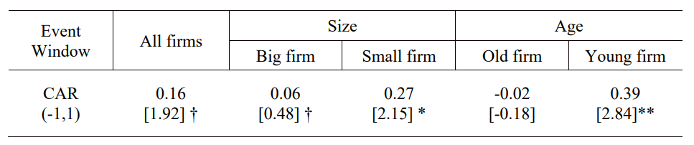
Table 3. Average Cumulative Abnormal Returns for the Event window
T-values are in square brackets.
†: p < 0.1
*: p < 0.05
**: p < 0.01

Table 4. Result of Ols Regression analysis
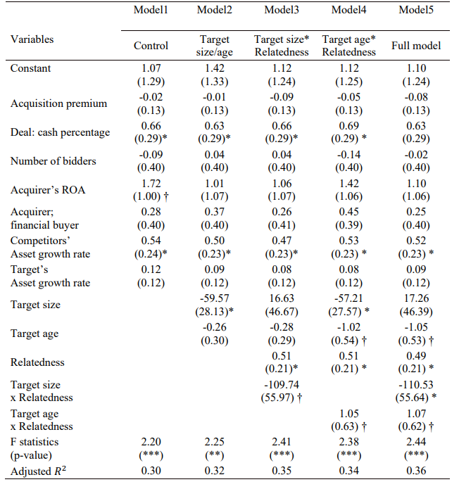
Standard errors are in parentheses. Year dummy variables and Industry dummy variables were included in all regression models. N=261
†: p < 0.1
*: p < 0.05
**: p < 0.01
***: p < 0.001
Figure 1. Theoretical Model
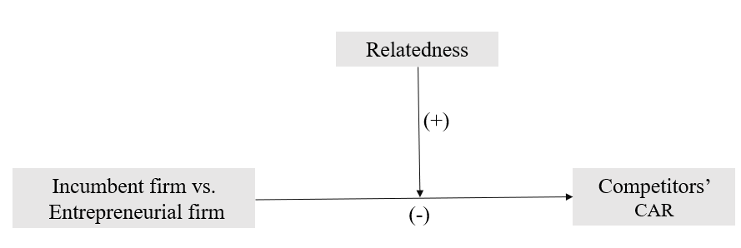

Figure 2. Moderating effect of relatedness on target size and competitors’ CARs
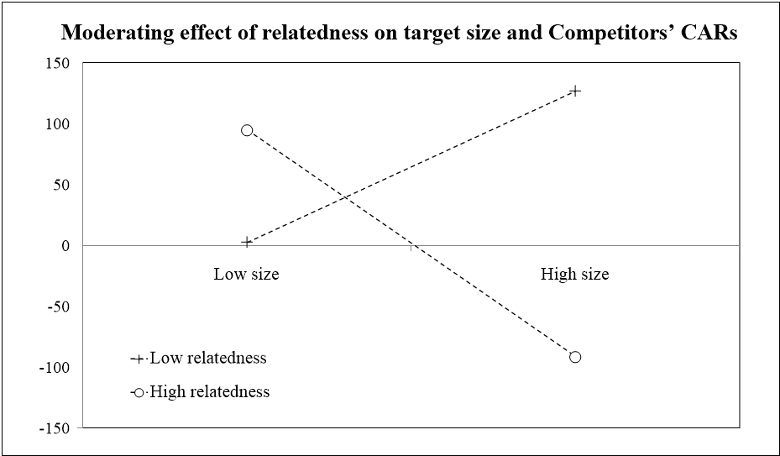

Figure 3. Moderating effect of relatedness on target age and competitors’ CARs
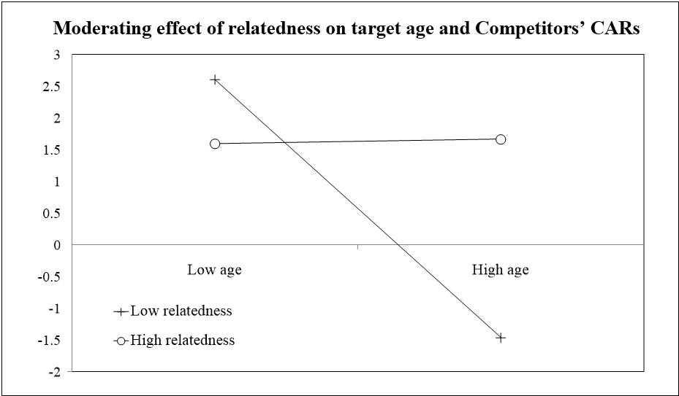

From Akdoğu’s (2009) analysis, competitors receive half-hopeful and half-gloomy signals from M&A. According to Akdoğu (2009), 55% of rivals earn negative abnormal returns around the M&A announcement, while Song and Walkling (2000) found that 64% of rivals got negative returns around a horizontal M&A.
Cumulative abnormal returns (CARs) to stock prices around the merger announcements are deemed to capture how M&A change competitors’ profit streams. It calculates the difference between the stock price firms actually gain around the event and what firms are expected to earn in the absence of the event. CARs have been frequently used to capture M&A performance in the short term (Asquith, 1983).
The latest literature has shown that positive CARs of competitors around the M&A are not only derived from increasing market power. By comparing the CARs to competitors around the horizontal and non-horizontal M&A, they evinced that competitors’ CARs are not more positive in horizontal M&A, where firms can engage in (silent) collusion (Derrien et al., 2007; Gaur et al., 2013; Song & Walkling, 2000; Testoni, 2021).
Rather than the competitors of acquirer, this type of argument has mainly explained the returns to the target’s competitors. Research suggests that further acquisition possibilities result in positive CARs to the competitors of targets (Akhigbe et al., 2000; Eckbo, 1983, 1985; Song & Walkling, 2000; Stillman, 1983).
Peteraf (1993) emphasized that the amount to be paid can highly influence the competitiveness of an M&A. Even if the target is highly competitive, overpayment would destroy the value of the M&A. However, recent literature found that acquisition premiums can signal the value of the target when its resources are difficult for the market to value (Laamanen, 2007).
Literature found that when acquirers pay using cash, shareholders associate such action with confidence in the deal and react more positively to it. We controlled it to prevent the payment method from signaling the value of the deal and potentially influencing competitors’ CARs.
Acquirer’s ROA of Gaur et al. (2013) shows a mean of 0.00 and SD of 0.10.
The competitor’s asset-to-growth-ratio in Gaur et al (2013) shows a mean of 0.18 and SD of 0.11.
according to managerial hubris argument, competitors’ returns can come from the anticipated M&A failures (Jemison and Sitkin, 1886; Roll, 1986).

