The Design and Practice of Expert System of Exercise Prescription
Professor: Bing Zhang
Sports and Health Research Center at Tsinghua University in China.

Purpose: Exercise prescription is designed to modulate acute exercise programming variables to create the adaptations desired by the individual or sport. With aerobic exercise prescription, the type of exercise, duration of exercise, frequency, and duration is adjusted. For resistance exercise prescription, the type of exercise, total session volume, rest period, frequency, and intensity are determined. Prescription of stretching and other activities is also commonly seen.

Method:
1.The expert system has set up four sub-systems in accordance with different purposes as: the rehabilitation therapy system for people with chronic disease; the strength exercise system for body builder; the weight-losing system for people want slim body shape; the health promotion system for people who want improve their heart-lung capability endurance.
2. Built up a strong knowledge base with consultative function. Based on the collection of the authoritative academic information home and abroad in many subjects including sports science, nutrition, psychology , etc. the system has edited and summarized 70 articles.
3. Computer processing to make the expert system software come true.

Result:
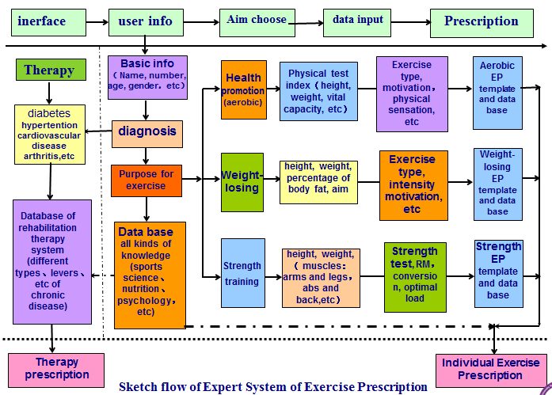
Conclusion:




Key words:
Exercise Prescription,Expert System, Software.

kyhymn@skku.edu

